**Scenario:** You are part of a DevOps team tasked with setting up the infrastructure for a new application in AWS using Terraform. The infrastructure includes:

1. A VPC with two public and two private subnets across two availability zones.
2. An EC2 instance in one of the public subnets to act as a bastion host.
3. A private RDS instance for the database in one of the private subnets.
4. S3 buckets for application logs and backups.
5. The infrastructure must be modular and reusable.

**Question 1:**

* How would you organize your Terraform code to implement this infrastructure while ensuring modularity and maintainability?

├── modules

│ ├── vpc

│ │ ├── main.tf

│ │ ├── variables.tf

│ │ ├── outputs.tf

│ ├── ec2

│ │ ├── main.tf

│ │ ├── variables.tf

│ │ ├── outputs.tf

│ ├── rds

│ │ ├── main.tf

│ │ ├── variables.tf

│ │ ├── outputs.tf

│ ├── s3

│ ├── main.tf

│ ├── variables.tf

│ ├── outputs.tf

├── environments

│ ├── dev

│ │ ├── main.tf

│ │ ├── variables.tf

│ │ ├── terraform.tfvars

**Question 2:**

* What steps would you take to handle sensitive data such as database credentials while deploying this infrastructure?

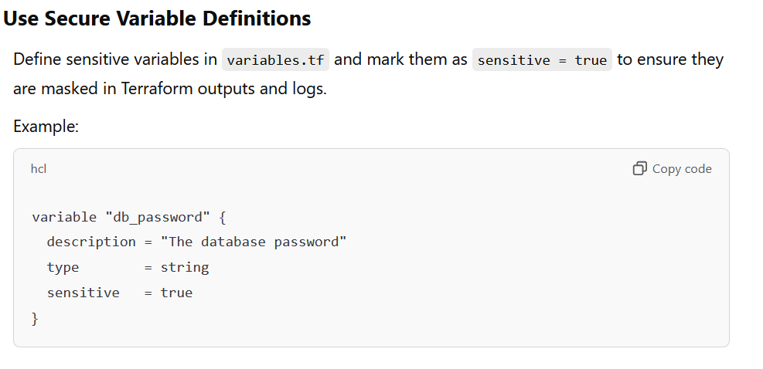

**Question 3:**

* After deploying the infrastructure, the application team informs you that the RDS instance needs to scale vertically (e.g., increase instance size). What steps would you take in Terraform to safely perform this change without disrupting other resources?

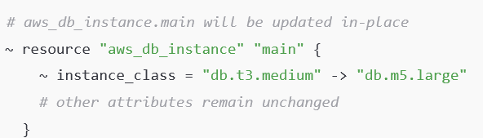

**Question 4:**

* The S3 bucket for logs needs a lifecycle policy to transition objects to Glacier after 30 days and delete them after 365 days. How would you implement this in Terraform?

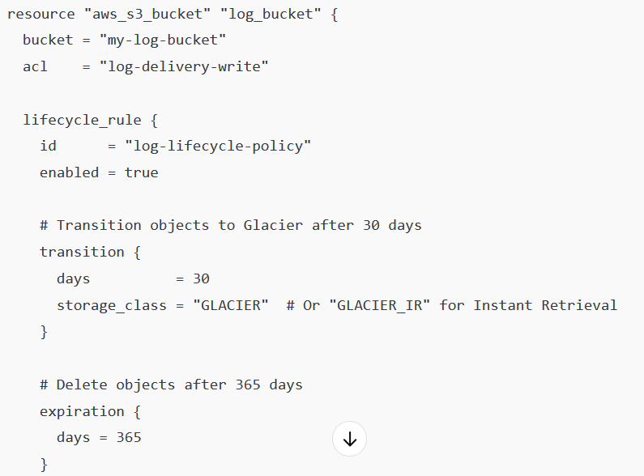

**Question 5:**

* How would you use Terraform's state file to manage changes, and what would you do if the state file is accidentally deleted or corrupted?

1) Implementing soft delete

2) use terraform import command to create statefile

3) take the backup of statefile before implementing any change.

**Question 6:**

* Provide me the details about infrastructure
  1. Multistage configuration
  2. Dependency between plan and apply
  3. Remote management of statefile.